Hemispheric specialization and recognition memory for abstract and realistic pictures: a comparison of painters and laymen

Stine Vogt^{a*} and Svein Magnussen,^{a,b}

ªDepartment of Psychology, University of Oslo, Norway

^{b}Centre for Advanced Study,

^{a,b} The Norwegian Academy of Science and Letters, Norway

Word count: main text 6197, abstract 100

*Corresponding author: Stine Vogt, Department of Psychology, University of Oslo, Box 1094 Blindern, 0317 Oslo, Norway. E-mail: s.e.vogt@psykologi.uio.no

Abstract
Recognition memory and hemispheric specialization were assessed for abstract colour/black and white pictures of sport situations in painters and visually naïve subjects using a forced choice yes/no tachistoscopic procedure. Reaction times showed a significant three-way interaction of picture type, expertise and visual field, indicating that painters processed the abstract pictures in the right hemisphere and sport pictures leftwards relative to the novices. The novices showed an overall LVF/RH advantage, strongest for sport pictures. The opposing gradients in the painters indicate a preferential change of processing strategy by which descriptive systems appear to have developed for figurative, but not abstract pictures.

Key words: recognition – hemispheric specialization – visual memory – artists –categorical – coordinate – analytical - perceptual constancy - expertise

1. Introduction
Cerebral lateralization has to a great extent been characterised in terms of dichotomies such as ‘verbal versus visuospatial’, ‘analytic versus holistic’ and ‘logical versus intuitive’ (Gazzaniga, Ivry & Mangun, 2002). Such approaches are basically descriptive and say little about how the two halves of the brain work together. As part of a general model of object recognition and visual imagery, Kosslyn, Koenig, Barret, Cave, Tang, and Gabrieli (1989) proposed a distinction in the processing of spatial relations in terms of categorical and coordinate visual properties by which categorical representations relate to general properties of the spatial structures of objects and scenes without defining physical proportions, and representations of coordinate spatial relations imply precise spatial locations of objects or parts in terms of metric units. Several studies have found that categorical processing is lateralized to the left, while coordinate processing is lateralized to the right hemisphere (see Jager & Postma, 2003 for a review). Kosslyn (1995) proposes that the right hemisphere represents specific visual forms in memory better than the left hemisphere, while the latter more efficiently represents abstract visual categories. Years ago, Goldberg and colleagues (Goldberg & Vaughan, 1978; Goldberg & Costa, 1981) proposed a somewhat similar approach, in terms of the Novelty-Routinization theory of hemispheric specialization. The Novelty-Routinization theory is part of a larger account of the dynamics of neocortical function. It associates novelty with the right hemisphere and cognitive routines with the left hemisphere. The hemispheres are described as being dynamic, relative and individualized (Goldberg, 2001). In place of the more traditional, modular apprehension of brain function, the Novelty-Routinization theory proposes a dynamic by which mental representations develop interactively in both hemispheres, but differing in the rates of their formations. While forming more rapidly in the right hemisphere in the early stages of learning of cognitive skills, the relative rate reverses in favour of the left hemisphere in later stages. Thus, the right and left hemispheres are adapted for gradiential processing as a function of the development of descriptive systems that are applicable to ongoing events (Goldberg, 2001).
Central to the Novelty-Routinization theory is the claim that the right hemisphere is critical for exploratory processing of novel situations in which no codes or strategies have been developed in the viewer’s cognitive repertoire. The left hemisphere is critical for the processing of stimuli involving pre-existing representations and routinized cognitive strategies. Specifically, the theory predicts a shift in the locus of control from the right to the left hemisphere as a function of the course of cognitive skill development (Podell, Lovell & Goldberg, 2001). An increasing number of functional neuroimaging studies provide support for the theory. Martin, Wiggs and Weisberg (1997) used Positron emission tomography (PET) to study blood flow patterns in subjects learning different kinds of information (meaningful words, nonsense words, real objects and nonsense objects) that was presented twice. They found a pervasive right to left shift of mesotemporal activation for all types of information; suggesting that the association of the right hemisphere with novelty and the left hemisphere with routinization is independent of the nature of information. Henson, Shallice and Dolan (2000) have reported similar findings. Using functional magnetic resonance imaging (fMRI), they found enhanced right-sided occipital fusiform activation with exposure to unfamiliar faces and symbols. Increasing familiarity was related to a decrease of right occipital activation and in increase of left occipital activation. Expertise studies of musical skill have also shown left hemisphere advantage as a function of training. Using fMRI to assess functional anatomy of musical perception in musicians, Ohnishi, Matsuda, Asada, Aruga, Hirakata, Nishikawa, Katoh & Imabayashi (2001) found left dominant secondary auditory areas in the temporal cortex and the left posterior prefrontal cortex during a passive music listening task for musicians but not for control subjects, who showed right hemisphere activation. Furthermore, Bhattacharya and Petsche (2001) found a significantly higher degree of phase synchrony in the gamma frequency (30-50 Hz) in musicians compared to musically naïve listeners. In addition, they observed a stronger phase synchrony in the left than in the right hemisphere in the musicians compared to the non-musicians. There are ambiguities and exceptions in relation to learning and a right-to-left processing gradient, however. For example, Laeng, Shah and Kosslyn (1999) found an initial left hemisphere advantage for encoding of animals in contorted positions, while subsequent performance for the same shapes yielded a right hemisphere advantage.
The accounts of Kosslyn (1994) and Goldberg (2001) approach hemispheric specialization from somewhat different vantage points and levels. Whereas the Novelty-Routinization theory emphasises a non-modular, non-specific transfer involved in the learning of cognitive skills associated with neocortical function, Kosslyn’s model was initially concerned with the documentation of distinct subsystems, each computing a particular type of representation of spatial relations. It is suggested that hemispheric differences may reflect the effects of habitual attentional biases rather than hard-wired structural differences (Kosslyn, 1994).
The study of expertise in painters may serve to link the two approaches in that the acquired ability to allocate attention to coordinate features in relation to producing figurative artwork may occasion learning profiles for low-level processes that do not arise in non-artists. Accordingly, we have evaluated the Novelty-Routinization theory by way of a comparison study of experienced painters and artistically unschooled participants viewing complex scenes with two common themes; abstract colour pictures and black and white pictures of ball players in game situations. As mentioned, several expertise studies have used musicians to study different effects of their training on perceptual processes (Battacharya & Petsche, 2001; Ohnishi et.al 2001; Gaser & Schlaug, 2003), yielding information about the auditive processing. Is visual processing subject to similar effects? Painters have a type of visual training that involves strong allocation of attention to perceptual, rather than categorical or conceptual features in objects and scenes. In order to depict a three dimensional scene on a flat surface, it is necessary to ignore the functions or connotations of what one is portraying. One needs to attend to the exact physical characteristics of the features one is portraying and their spatial locations. For example, ‘The girl is sitting on a chair’ is redundant to this purpose; one needs to properly apprehend the exact metric proportions, the precise modulations of the colours, the interaction of light and shaded areas that create the appearance of form, etc. This is a basic requisite for figurative rendition, and any contextual information must be subordinate. One may say that the purely pictorial aspects of a scene must be correctly apprehended in order to project any categorical, contextual or meaningful implications. This has been a concern of art teachers for centuries. The art historian E.H.Gombrich, reflecting on the duality of the visual experience, says:
“…they (art teachers) are also right when they insist that he must find means of battling down this knowledge of the familiar meaning of things and look only at shapes and tones projected onto an imaginary plane. We have seen that he can break down the constancies only if he ceases to attend to the meaning of things.” (Gombrich, 1959)
A variety of techniques have been devised in order to flout our natural tendency to extract meaning and invariance from scenes. For example, several woodcuts by the German artist and teacher Albrecht Dürer (1471-1528) depict ways and means of circumventing perceptual constancy, possibly inspired by Leonardo da Vinci’s (b. 1452, d. 1519) suggestion that perspective was nothing more than viewing a scene behind a pane of transparent glass on the surface of which the objects behind the glass can be drawn. This is referred to as a ‘da Vinci window’. In one frequently reproduced picture (Fig.1), an artist is shown while attempting to circumvent size constancy by portraying a reclining woman viewed through a transparent pane with a grid, transcribing her features piece by piece as guided by the confines of the individual cells of the grid, thus enabling him to distribute the features of the model accurately in terms of locations and relative size as they emerge in foreshortening.

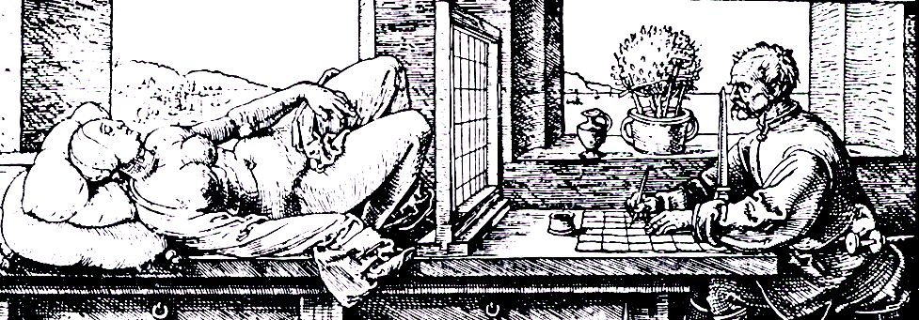

Fig. 1: Albrecht Dürer: Woodcut, about 1527

Reith and Liu (1995) used a da Vinci window to assess hindrances to accurate depiction of projective shape. They had adult subjects draw the visual projection of two models, one a trapezoid and the other a tilted rectangle in the frontoparallel plane. They found that the projected shape of the trapezoid was drawn accurately, but the the tilted rectangle was systematically distorted in the direction of its actual dimensions. Thus, even with the help of a da Vinci window, the subject’s knowledge of the real shape of the model influenced performance.
The properties that must have priority in figurative rendition, i.e. the exact proportions and not those associated with stored representations of models, correspond with a coordinate, as opposed to a categorical spatial relations view (Kosslyn, 1987; Kosslyn et al., 1989; Laeng, 1994). As mentioned, categorical representations relate to general properties of the spatial structures of objects and scenes without defining physical proportions, and representations of coordinate spatial relations imply precise spatial locations of objects or parts in terms of metric units. Categorical perception would include size and form constancy, the ability to extract object invariance across differing locations and orientations. Evidence of dissociable neural subsystems for viewpoint dependent (right hemisphere) and viewpoint independent (left hemisphere) processes has been found (Brewer Zhao & Desmond, 1998; Burgund & Marsolek 2000). Davidoff and Warrington (1999) found that the conventional view of objects is lateralized to the left, and objects perceived in unconventional perspectives were processed in the right hemisphere. Laeng, Zarrinpar and Kosslyn (2003) found that the left hemisphere was specialised for identifying objects at their basic level (e.g. ‘bird’ rather than ‘robin), while the right hemisphere was specialised for identifying objects as specific exemplars. A comparable differentiation has been formulated for colour perception (Troost, 1998) in the terms analytical versus categorical views. The analytical view refers to the discrimination of sensory colour differences to the optimal degree of the visual system’s ability to perceive. A categorical perception denotes the grouping of visual input into more conceptually manageable units. For example, traffic lights are red, yellow or green. The discrimination of variations in these colours would be time consuming, unnecessary and dangerous in the context of negotiating traffic. To our knowledge there are no studies of the lateralization of categorical and analytical colour perception per se. However, a number of studies (Njemanze, Gomez & Hornstein, 1992; Mendola, Rizzo & Cosgrove, 1999) have found that colour discrimination tends to be lateralized to the right hemisphere. Colour constancy, the ability to extract colour invariance across large variations in the spectral content of the illumination, is compromised by unilateral lesions in both hemispheres (Rüttiger, Braun & Gegenfurtner, 1999), and bilateral processing is also found for naturalistic scenes in healthy subjects (Golby, Poldrak, Brewer, Spencer, Desmond, Aron & Gabrieli, 2001). One may infer that extraction of colour invariance plays a part in this. The existence of separate categorical and analytical/coordinate views has obvious survival value: some situations need fast, decisive action (e.g. negotiating traffic), and some need deliberation and discrimination (e.g. judging the edibility of food by its colour).
The Novelty-Routinization theory would predict that schemas for the handling of
perceptual features independently of their non-visual aspects are developed in experienced painters as a function of the increased allocation of attention to the exact physical properties of scenes and objects in favour of extracting invariance and meaning, as is the natural tendency for all viewers. Thus, to the extent that the production of artwork influences cognitive processing, both figurative colour abstract pictures and realistic pictures in black and white should elicit a left-hemisphere advantage in painters. Conversely, a right hemisphere advantage would be expected in visually naïve subjects. With regard to the degree to which the production of artwork influences behaviour, studies of eye movement behaviour (Vogt, 1999; Vogt and Magnussen, submitted) have shown that artists attend more to abstract form and colour features of complex scenes than novices. Thus, visual behaviour appears to be influenced by expertise. The study included a test of recall, the results of which showed that the artists did not remember more pictures, but that their recall of different picture features of both conceptual/categorical as well as perceptual features significantly exceeded that of the novices. The study comprised pictures ranging from very mundane scenes to abstract pictures. This was done in order to assess whether pictures that could be viewed as works of art would be viewed differently from ordinary scenes. No scanning differences were observed between picture types, and the between group differences that were observed were consistent for the picture types.

The present study
Since colour constancy/colour scenes (categorical) are processed bilaterally, (Rüttiger et.al, 1999) as opposed to the lateralized functions of colour discrimination (analytical) and form and size constancy (categorical), and since it is the enhanced ability for analytical processing that is thought to be influenced by training, we decided to study colour configuration and object perception separately. This would also allow us to study complex configurations independently of objects and scenes. Studies of complex colour scenes often discuss colour in relation to objects (Wurm, Legge, Isenberg & Luebker, 1993; Hanna & Remington, 1996; Suzuki & Takahashi, 1997; Gegenfurtner & Rieger, 2000; Thorpe, Gegenfurtner, Fabre-Thorpe & Bülthoff, 2001), thereby possibly biasing colour processing towards categorical properties. We used a tachistoscopic procedure to assess recognition memory and hemispheric lateralization for two types of pictures: black and white photographs of ball players and abstract colour pictures (all designed by the first author). Pictures of ball players were chosen for their similarity to the poses of human models with which the painters participating in the study had comprehensive experience. The art training of all subjects entailed daily practice with both long-term poses in which the model held the same pose for a week or two, and croquis situations in which a model changes positions every five to ten minutes. Since many studies have shown that realistic colour enhances recognition, we used black and white realistic pictures so as not to confound facilitatory colour effects for realistic objects/scenes with the effect of colour and form on their own. The black and white sport pictures were degraded somewhat by using the sketch filter options ‘graphic pen’ and ‘contè crayon’ in the attempt to disguise facial features of individual (famous) players, and all insignia with cues for team affiliation, lettering etc. were removed. The resulting stimuli provided relatively little access to category variety, which would bias processing to the left hemisphere. The abstract pictures were made so as to preserve the complexity of natural scenes without containing recognisable objects (see fig. 2 for examples of both picture types). These pictures were based on colour photographs for input, thus providing the perceptual richness we wished to assess. The pictures were made non-figurative by way of different selection/deletion and layering options that were subjected to colour inversion and adjustment as well as freehand ‘painting’ using a Wacom touch-pad. The resulting picture types allowed for a separate assessment of whether or not colour/form configurations are amenable to training effects. The abstract pictures were susceptible to both categorical/verbal and analytical processing. They could be encoded as colour configurations and/or as configurations resembling stored representations. It is well known to most painters showing their abstract work that their (untrained) audience will very often try to find recognisable objects with which to compare it. This phenomenon may reflect observed eye-movement patterns in naïve viewers: when there is a choice of abstract and figurative attributes in one picture, visually naïve viewers tend to spend significantly more of the time then artists viewing the figurative elements (Yarbus, 1967; Vogt and Magnussen, submitted). Furthermore, in a second viewing of the same pictures, they will increase viewing time for these features in fewer and longer fixations (Althoff & Cohen, 1999; Ryan & Althoff, 2000), thus presumably consolidating the encoding of meaningful features.
Our first hypothesis is that any observed differences in the pattern of behaviour between groups will be due to artistic experience. Secondly, we hypothesise that novices will attempt categorical processing for both picture types, and that this will lead to a higher degree of right hemisphere lateralization for the sport pictures since these provide the least access to categorical cues, and since these subjects have no experience involving specific attention to the handling of coordinate, or perceptual features per sè. A lesser degree of lateralization is predicted for the abstract pictures as a function of increased
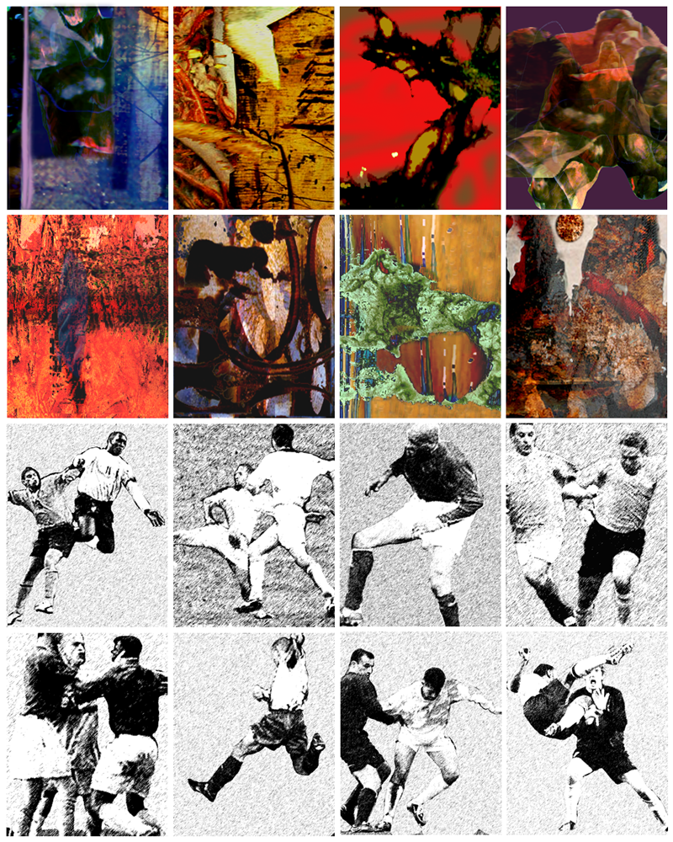
Fig.2. Examples of abstract colour pictures and black and white sport pictures used in the experiment.

associations with long-term memory representations. For the artists, we hypothesise a left hemisphere advantage for both picture types as a function of developed schemas for the independent handling of purely perceptual features.

2. Method

2.1 Participants

The group of artists comprised 16 right-handed painters, 9 women and 7 men, recruited from the National Association for Norwegian Painters. Ages varied between 23 and 66, average age was 41. All had been educated at the National College of Arts and Crafts and/or the National Academy of Fine Arts, both in Oslo. All but one of the subjects had held separate exhibitions in Oslo and all had undergone basic training in painting and drawing from models. A group of 16 right-handed, visually untrained subjects, 8 women and 8 men, were recruited from among the scientific staff (as well as two students from the graduate program) at the University of Oslo, Department of Psychology. Ages varied from 24 to 53, mean age was 39 years. Thus, the groups were reasonably well matched with regard to professional experience and age. Handedness was assessed by the Edinburgh Handedness Inventory (Oldfield, 1971). Subjects all had normal or corrected to normal vision, and reported no colour blindness on questioning.

2.2 Stimuli

Two types of pictures, abstract and object based, with 80 pictures of each type, were produced for the experiment using Adobe Photoshop. The abstract pictures were in colour, made so as to preserve the variety of complex scenes without containing any recognisable objects. In order to ensure that the pictures were in fact abstract and did not give rise to similar figurative associations, a group of 5 people were asked to view a random selection of 5 of the pictures and to report their associations for them on a questionnaire (“what do you think these 5 pictures look like?”). The reports gave rise to associations with identifiable objects, but none of these were alike or similar for any of the participants. The likeness to objects was thus idiosyncratic and did not reflect any inadvertent similarity to recognisable objects in the pictures themselves. The second type of picture represented situations from ball games taken from the Internet. They were rendered black and white and somewhat grainy so as to prevent recognition of faces for those who had knowledge of ball players. For the same reason, all insignia, lettering and other features related to team affiliation that could be identified by a sports fan were edited out, including the ball. The remaining material thus comprised pictures of one, two or three players in action. Pictures subtended 11° vertically and 9° horizontally and were presented with the inner border 3° off centre. Presentation time for the pictures was 150 msec, which is the minimum time estimated for complete processing of images (Thorpe, Fize & Marlot (1996).

2.3 Procedure

The participants were tested individually. Following assessment for handedness, they were told that the experiment was a test of memory for different types of pictures, and that they should respond as quickly as possible. The subject was seated comfortably in front of the monitor and stabilised with a chinrest at a distance of 53 cm. For the learning trial, they were instructed to try to remember the pictures they were to view. Twenty of the pictures were presented in the centre of the screen for 5000 msec each, with intervals of 600 msec. Following the learning trial, the subjects received on-screen instructions to the effect that after a key press, a cross would appear in the centre of the monitor and that they were to carefully focus on this; that after 2 seconds, a previously seen or a previously unseen picture would be flashed very rapidly on the left or right side of the cross, and that they were to press 1 if they did not recognise the picture and 2 if they did. Although there is reason to think that collecting data in this way will entail a Simon effect yielding an advantage for right visual field presentations, we chose not to take this into account, since such advantage would be too small (approximately 4 msec according to a meta-study by Marzi, Bisiacci & Nicoletti, 1991) to make a difference. Subjects were reminded verbally to fixate at each picture presentation. A practice trial was given, using other pictures than those included in the experiment. When the procedure was rehearsed, the experiment commenced. Picture types were presented in two separate blocks, with all picture sequences randomised. The learning sequence comprised 20 pictures of the current trial, either abstract or sport, followed by test trials comprising these targets among 60 distractors. To preclude any effects of individual pictures, the trials were divided into 4 groups in which the targets comprised either pictures 1-20, 21-40, 41-60 or 61-80, balanced across the groups. The presentations were offset by the cross in the centre of the screen (vertical and horizontal), duration 2000 msec, followed by a 150 msec exposure to the right or left of the centre, with the response to one picture generating the next cross/picture presentation. Stimuli were displayed on a 21” Eizo FlexScan T 960 monitor set at a resolution of 768 x 1024 pixels.

3. Results
The proportion of correct responses was 76.1% for the artists and 72.9% for the novices. The accuracy data were subjected to a signal detection analysis, and the sensitivity or discrimination performance (d’) of the two groups is plotted in Fig. 3. There is no over-all differences between the groups, but there is a main effect of condition, F (1.30) = 4.194, p < .05, favouring the sport pictures, a main effect of visual field, F (1.30) = 7.595, p < .01, showing a left visual field/right hemisphere advantage, and an interaction of visual field and condition, F (1.30) = 4.657, p < .05. However, when the groups were analysed separately, we found that whereas no significant differences or interactions were found for either visual field or condition in the group of artists, an effect of visual field was found for the novices, F (1.15) = 5.618, p < .03, favouring the left visual field/right hemisphere, as well as an interaction of visual field and condition, F (1.15) = 4.658, p < .05, showing greater lateralization for the sport pictures. No effect of condition was found for the novices in this analysis.

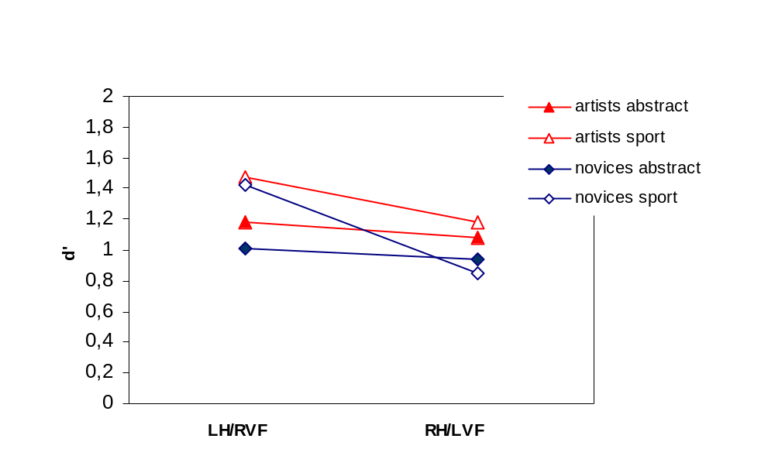
Fig. 3. Recognition memory, assessed by d’, for abstract and figurative (sport) pictures in the left and right visual field, for professional artists and artistically naïve participants.

Since the highest number of possible correct responses was only 20, yielding insufficient data for further differentiation of lateralisation along the dimensions of correct identification/correct rejection, we collapsed all correct responses and analysed the reaction time data, rejecting those over 3 standard deviations, comprising 1.5%. The results are shown in Fig. 4. Repeated measures ANOVA shows a main effect of picture type (condition), F (1.30) = 18.464, p < .001, showing that the abstract pictures were recognised more quickly than the football players for both groups.

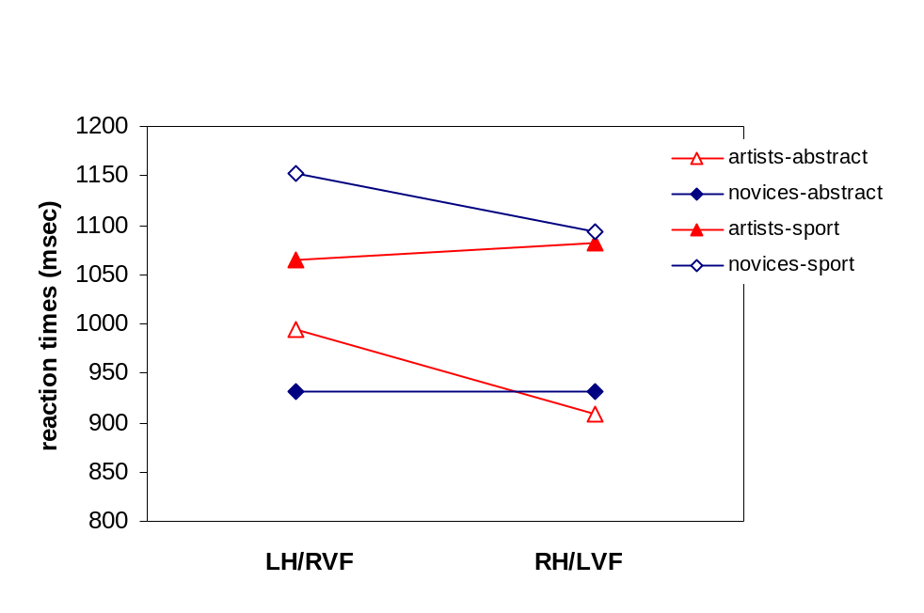
Fig. 4. Reaction times for correct responses in the left and right visual fields, plotted separately for picture type (abstract versus figurative) and subject group (artists versus novices).

Thus, we see a slight overall speed-accuracy trade-off between conditions, indicating that abstract pictures were processed quickly at the expense of accuracy, and the sport pictures were processed more accurately at the expense of time. There was no main effect of visual field in the analysis of reaction times, but a three-way subject group by picture type by visual field interaction, F (1.30) = 11.325, p = .002, reflects a pattern by which performance in the group of artists deviates from that of the novices; whereas the latter have a consistent tendency towards a left visual field/right hemisphere advantage, the performance of the artists shows that their processing of abstract colour pictures lateralizes to the left visual field/right hemisphere to a greater degree than in the novices, and that their processing of sport pictures tends towards the opposite visual field/hemisphere (Fig. 4). A separate analysis of the groups supports this: in the novice group, no main effect of visual field was found, and a picture type/visual field interaction: F (1.15) = 6.789, p = .02, reflecting the rightward gradient for the sport pictures. In the group of painters, no main effect of visual field was found, and a picture type/visual field interaction: F (1.15) = 5.521, p = .03, indicating the LVF/right hemisphere advantage for the abstract pictures (the converse pattern than found for the naïve group). T-tests for visual field differences showed that for the group of novices, the sport pictures yielded a rightward hemispheric lateralization effect: t (1.15) = -2.473, p < .03, while no effect of lateralisation was found for abstract pictures, while the opposite obtained for the artists: no lateralization effect was found for sport pictures, while the abstract pictures yielded the effect of: t (1.15) = -2.282, p < .04. Thus, d’ is consistent with reaction times in relation to hemispheric lateralization.

4. Discussion
The most striking finding was the three-way interaction in response times between picture type, expertise and visual field. Whereas the naïve group of subjects had a tendency towards a LVF/RH advantage for both stimulus types, particularly for the sport pictures, the painters showed the opposite pattern; a leftwards gradient for the sport pictures and a strong rightward gradient for the abstract pictures. Relatively to the novices, the artists processed the sport pictures further to the left and the abstract pictures further to the right. Thus, for long-term effects, results for only the sport pictures support the Novelty/Routinization theory when performance was compared between groups. When compared to the study by Laeng et.al (1999), in which results showed an initial RVF/LH advantage for animals in contorted positons and a subsequent LVF/RH advantage for the same pictures, our results may be ambiguous in relation to the potential (unassessed) shift that may have occurred from the learning trial to the test trial. There are important differences between the present study and theirs. In addition to differences in the general design, we assessed scenes and not separate objects; contortions were not systematic, we used human beings and not animals in different positions and we did not assess immediate processing, using instead a learning trial (no assessment) and test trials. The two studies nonetheless afford interesting points of comparison. The results for the novices were similar to those found in the study by Laeng et. al (1999), in which they found a LVF/RH advantage for previously viewed pictures of non-rigid forms (animals) in contorted positions. Their hypothesis predicted a RVF/LH advantage when first encoding pictures of animals in contorted poses as a function of the right hemisphere’s specialisation for processing categorical spatial features. They hypothesized that object identification of familiar forms in contorted poses is attained by first encoding the object’s parts separately, encoding the spatial relations among the parts and matching the encodings to stored structural description. Further, they hypothesized that following presentations of the same pictures would elicit a LVF/RH advantage as a function of a change of strategy towards direct matching to stored representations by was of assessing overall, global shape with familiarity. The study by Laeng et. al (1999) assessed both initial presentation and subsequent presentation of the same pictures, and found support for their hypothesis. The present study did not assess any performance for initial presentation, relying instead on very long-term effects of dealing with more or less contorted human figures, represented in painters with training in depicting human models. Thus, if we extrapolate from the observations made in the study by Laeng et al. (1999), the results we see for novices responding to the sport pictures may be the result of a left to right hemispheric shift from the learning trial to the test trial, and could in this event be assumed to be consistent with their findings. Since we did not assess performance for initial presentation (i.e. the learning trial) we do not know whether any comparable immediate shifts occurred from the learning trial to the test trial for the painters. We can assess very long-term effects of their drawing and painting skills, however. As mentioned, the painters’ performance for sport pictures lateralizes significantly to the left of the novices. Thus, in the long-term view, the Novelty/routinisation theory is supported for the sport pictures. According to the hypothesis of Laeng et. al (1999), this would indicate that no preferential strategy shift has occurred in the painters, and that they stayed with an encoding strategy in which they memorised the sport pictures as abstract spatial configurations of human bodies, their respective parts and the actions involved (entailing a relative RVF/LH advantage). That no learning has taken place in subjects with extensive experience in rendering the human figure is counterintuitive, however. Laeng et.al (1999) hypothesise that the shift towards overall, global identification is cost efficient. This is countered by our results for the sport pictures in that performance in the painters is no worse, but rather better than the in the novices. Since we observe no performance detriment, either in the present study or in our previous study of eye movements and recall memory (Vogt, 1999; Vogt and Magnussen, submitted), it may be that artists are able to achieve cost efficiency in other ways. The tendency for artists to attend to and recall more features in pictures, both realistic and abstract, as well as the conspicuous absence of eye-movement priming (i.e. fewer and longer fixations at previously selected locations in second viewings) in artists may perhaps indicate that they are better able to make use of quantity and variety in visual input, rather than selecting features to match with stored representations and rehearsing them by way of extra scanning.
We observe that training has had a different influence on the two picture types, as observed in the three-way interaction of reaction times, showing that the abstract pictures lateralize to the right in the painters relative to the novices. This indicates that they may have memorised the pictures as specific visual instances, as opposed to the novices, who appeared to process the abstract pictures according to a strategy of matching to stored representations, as evidenced in the relative leftward lateralization. A possible explanation for the opposing gradients observed in the artists in relation to the two picture types may be that the production of figurative and abstract works of art involve different types of motor activity. Drawing and painting from models involves a very high degree of hand-eye coordination in order to achieve veridical depiction, particularly in the case of human models. This does not obtain for abstract works because there is no online matching of features in the environment, associated with precise arm and hand movements. It may be that the relatively repetitive motor activity involved in figurative work may elicit comparable expertise effects as those found in musicians (Gaser & Sclaug, 2003; Jäncke, 2002; Schmithorst & Wilke, 2002; Semmler, Sale, Meyer & Nordstrom, 2004); musical training also involves the development of fine motor skills in conjunction with cognitive processes.
Regarding the pattern of results obtained for the abstract pictures, and if we accept the proposal that the artists do not process colour configuration categorically, the rightward gradient for the abstract pictures indicates that colour configurations on their own are not susceptible to the generation of schemas, and that descriptive systems for visual processing may be related to recognisable objects and scenes. It is worth noting in this context that all of the artists in this study had vastly more experience working with colour than with models. Whereas work with models is an activity that most artist in this study had abandoned in favour of more abstract work, attention to colour is a crucial feature of virtually any visual art form, be it conception art, constructivism, video art or installation, all of which obviously require the ability for analytic colour processing. In spite of this, it appears that figurative work with models gives rise to lasting schemas or routines while colour processing seems impervious to such effects.
Where concerns recognition memory performance for the two groups, it should be kept in mind that since painters are attentive to a greater variety of visual features than laymen (as mentioned, this is observed in their eye-movement behaviour), equal performance in the present study does not necessarily mean equal recognition capacity. If one accepts the logic inherent in increased attention to a greater variety of visual cues as a function of training and experience with picture production, it follows that artists are able to handle a greater spate of information at the same performance level as novices. It is possible that the lateralization pattern found in the artists, by which the object based black and white pictures was lateralized to the left, relative to the colour/form pictures, is an expression of a functional adaptation by the visual system to accommodate this increase in information. If our primary hypothesis is correct, i.e. that any observed between-group differences are due to expertise, then the present findings support earlier findings that colour discrimination is lateralised to the right (Njemanze et al., 1992; Mendola et al., 1999;) and that the memory performance of artists enhances this view in that they are trained in analytical colour processing, i.e. they may be supposed to be less likely to prefer categorical processing as a function of their training.
Performance for abstract pictures was no worse than for sport pictures in either group. This indicates that colour cues facilitate memory performance independently of diagnostic value, i.e. adding familiar description to known objects, and that encoding and retrieval of cue variety does not depend on an association with recognisable objects. However, rich colour variation on its own does not ensure good memory performance. In a study of long-term memory for pictures with a common theme – photographs of 800 doors - with a systematic reduction of cues in three conditions in which the final pictures comprised only the intact colour configurations of the pictures and no variation in spatial frequency, memory performance fell to chance level (Vogt and Magnussen, submitted). This finding, combined with the good memory performance found for abstract colour pictures in the present study suggests that the benefits of colour information depend on the presence of some sort of basic form unit perception. It may be that we cannot encode information without figure/ground perception, and that when there are no distinct figures present in a complex configuration of colour and form, the system selects features in order to create them. This is in accordance with an investigation of whether the visual system is free to select arbitrary visual locations and features as comprising figures, in which Braun (2000) defines visual objects as a cluster of locations and features conforming to the Gestalt rules of visual completion. Using a paradigm derived from attentional tracking (Blaser, Pylyshyn & Holcombe, 2000) it was found that attention selects the features of one object, task relevant or not, as the figure, i.e. attention selects a visual object as a ‘whole’; a set of locations and attributes that are linked by Gestalt rules (Braun 2000). Extrapolating to the present context, it may be that ‘wholes’ are extracted from within the abstract configurations on the basis of the same rules, and that this extraction defines a more basic premise for the encoding of colour than its facilitatory effect on memory for recognisable objects.
The study of visual artists can serve several purposes: we may learn more about artists, which appears to be the main concern of most studies involving them (Putko, 1989; Cupchik, Winston & Herz, 1992; Nodine & Locher, 1993; Solso, 2001) and we may learn something about processing dynamics in the population at large. The latter is only possible with a well-developed hypothesis about the specific processes artists undergo. If there is no formulated idea about why artists should perceive the world differently from others, studies involving them as subjects will at best only result in educated guesswork. Studies of subjects with specific brain damage proceed from knowledge about the lesion sites and their purported functions, and there is no reason why studies of subjects with given areas of expertise should not do likewise. Studies of cognitive expertise tend to assess very specific domains, such as face recognition (Gauthier & Tarr, 1997; Gauthier et.al, 2000; Rossion et.al, 2002) or higher level domains involving e.g. memory for game situations, such as parallel encoding of chess situations (Reingold, Charness, Schultetus & Stampe, 2001) or differences between expert and novice snooker players (Abernethy, Neal & Koning, 1994). The fact that portraying models - any models – requires the ability to dissociate categorical information from perceptual features and their coordinate spatial relations lends the skills of artist a considerably more extensive area of expertise at more primary perceptual processing levels than can be observed from more domain specific studies. This is a resource that may provide valuable information about the dynamics of the normal visual system, complementing work in cognitive neuropsychology.

Acknowledgements
This study was supported by the Norwegian Research Council (MH). We thank D.E. Eilertsen for assistance with statistical analyses.

References

Abernethy B., Neal R. J.& Koning P. (1994). Visual-perceptual and cognitive differences between expert, intermediate and novice snooker players. Applied Cognitive Psychology 8, 185-211.

Althoff, R.R. & Cohen, N.J. (1999). Eye-movement based memory mffect: a
reprocessing effect in face perception. Journal of Experimental Psychology: Learning, Memory and Cognition, 25, 997-1010.

Bhattacharya, J. & Petsche, H. (2001). Musicians and the gamma band: a secret affair?
Neuroreport, 12, 371-374.

Blaser, E., Pylyshyn, Z. W. & Holcombe, A. O. (2000). Tracking an object
through feature space. Nature, 408, 196–199.

Braun, J. (2000). Intimate attention. Nature, 408, 154 –155.

Brewer, J. B., Zhao, Z., Desmond, J. E., Glover, G. H. & Gabrieli, J. D. E.
(1998). Making memories: activity that predicts how well visual experience will be remembered. Science, 281, 1185–1187.

Burgund, E. D. & Marsolek, C. H. (2000). Viewpoint-invariant and viewpoint-
dependent object recognition in dissociable neural subsystems. Psychonomic Bulletin & Review, 7, 480-489.

Cupchik, G. C., Winston, A. S. & Herz, R. S. (1992). Judgements of
similarity and difference between paintings. Visual Arts Research, 18, 37-50.

Davidoff, J., & Warrington, E. K. (1999). The bare bones of object recognition;
implications from a case of object recognition impairment. Neuropsychologia, 37, 279 –292.

Gaser, C. & Schlaug, G., 2003. Brain structures differ between musicians and non-
musicians. The Journal of Neuroscience, 23, 9240-9245.

Gauthier, I.& Tarr, M. (1997). Becoming a “Greeble” expert: exploring mechanisms for
face recognition. Vision Research, 37, 1673-1682.

Gauthier, I., Skudlarski, P., Gore, J.C. & Anderson, A.W. (2000). Expertise for cars and
birds recruits brain areas involved in face recognition. Nature Neuroscience, 3, 191-197.
Gazzaniga, M. S., Ivry, R.B. & Mangun, G. R. (2002). Cognitive Neuroscience: The
Biology of the Mind. London: Norton.

Gegenfurtner, K. A. & Rieger, J. (2000). Sensory and cognitive contributions of
color to the recognition of natural scenes. Current Biology, 10, 805-808.

Golberg, E. & Vaughn, H. G. jr. (1978). Nonverbal descriptive systems and
hemispheric asymmetry; shape versus texture discrimination. Brain and Language, 5, 249-257.

Goldberg, E. & Costa, L. D. (1981) Hemispheric differences in the acquisition
and use of descriptive systems. Brain and Language, 14, 144-173.

Goldberg, E. (2001). The Executive Brain: Frontal Lobes and the Civilized Mind, pp 45-
46. Oxford University Press Inc., New York.

Golby, A. J., Poldrak, R. A., Brewer, J. B., Spencer, D., Desmond, J. E., Aron,
A. P. & Gabrieli, D. E. (2001). Material-specific lateralization in the medial temporal lobe and prefrontal cortex during memory encoding. Brain, 124, 1841-1854.
Gombrich, E.H. (1959). Art and Illusion, p. 258-9. Phaidon Press, UK.

Hanna, A. & Remington, R. (1996). The representation of color and form in long-
term memory” Memory and Cognition, 24, 322-330.

Henson, R., Shallice, T. & Dolan, R. (2000). Neuroimaging Evidence for Dissociable
Forms of Repetition Priming. Science, 287, 1269-1272.

Jager, G. & Postma, A. (2003). On the hemispheric specialization for categorical
and coordinate spatial relations: a review of the current evidence” Neuropsychologia, 41, 504-515.

Jäncke, L., 2002. The case of a left-handed pianist playing a reversed keyboard: a
challenge for the neuroscience of music. NeuroReport, 13, 1579-1583.

Kosslyn, S. M. (1987). Seeing and imagining in the cerebral hemispheres: a
computational approach. Psychological Review, 94, 148–175.

Kosslyn, S. M., Koenig, O., Barret, A., Cave, C. B., Tang, J. & Gabrieli, J. D. E.
(1989). Evidence for two types of spatial representations: hemispheric specialization for categorical and coordinate relations. Journal of Experimental Psychology: Human Perception and Performance, 15, 723 – 735.

Kosslyn, S.,1994. Image and Brain: the Resolution of the Imagery Debate, pp.191-245.
MIT Press, U.K.

Laeng, B. (1994). Lateralization of categorical and coordinate spatial functions: a study
of unilateral stroke patients. Journal of Cognitive Neuroscience, 6, 189-203.

Laeng, B., Shah, J. & Kosslyn, S. (1999). Identifying objects in conventional and
contorted poses: Contributions of hemisphere-specific mechanisms. Cognition, 70, 53-85.
Laeng, B., Zarrinpar, A. & Kosslyn, S.M. (2003). Do separate processes identify
objects as exemplars versus members of basic-level categories? Evidence from hemispheric specialization. Brain and Cognition, 53, 15-27.

Martin, A., Wiggs, C.L. & Weisberg, J. (1997). Modulation of Human Medial
Temporal Lobe Activity by Form, Meaning and Experience. Hippocampus, 7, 587-593.

Marzi, C.A., Bisiacci, P. & Nicoletti, R., 1991. Is interhemispheric transfer of
visuomotor information asymmetric? Evidence from a meta-analysis. Neuropsychologia, 29, 1163-1177.

Mendola, J. D., Rizzo, J. F., Cosgrove, G. R., Cole, A. J., Black, P. & Corkin, S.
(1999). Visual discrimination after anterior temporal lobectomy in humans. Neurology, 52, 1028-1036.

Njemanze, P. C., Gomez, C. R. & Horenstein, S. (1992) Cerebral lateralization
and color percpetion: a transcranial doppler study. Cortex, 28, 69-75.

Nodine, F., Locher, P. J., Krupinski, E. A., (1993). The role of formal art training
on Perception and aesthetic judgement of art compositions. Leonardo, 26, 219-227.

Ohnishi, T., Matsuda, H., Asada, T., Aruga, M., Hirakata, M., Nishikawa, M., Katoh, A.
& Imabayashi, E. 2002. Functional anatomy of musical perception in musicians.
Cerebral Cortex, 11, 754-760.

Oldfield, R. C. (1971). The assessment and analysis of handedness: The
Edinburgh Inventory. Neuropsychologia, 9, 87 – 113.

Podell, K., Lovell, M. & Goldberg, E. (2001). Lateralization of Frontal Lobe
Function, pp. 83-99. In the Frontal Lobes and Neuropsychiatric Illness, Stephen P. Salloway, Paul F. Malloy, James D. Duffy (Eds). American Psychiatric Publishing Inc. USA.

Putko, A. (1989). Cognitive interpretation of works of art in the artist’s and the
layman’s unsophisticated experience. Polish Psychological Bulletin, 20, 33- 41

Reingold, E.M., Charness, N., Schultetus, R.S. & Stampe, D.M. (2001). Perceptual
automaticity in expert chess players: parallel encoding of chess relations. Psychonomic Bulletin and Review, 8, 504-10.

Rossion, B., Gauthier, I., Goffaux, V., Tarr, M.J. & Crommelinck, M. (2002). Expertise
training with novel objects leads to a left-lateralized facelike electrophysical response. Psychological Science, 13, 250-257.

Rüttiger, L., Braun, D. I., Gegenfurtner, K. R., Petersen, D., Schönle, P. &
Sharpe, L. T. (1999). Selective color constancy deficits after circumscribed unilateral brain lesions. The Journal of Neuroscience, 19, 3094-3106.

Ryan J. D., Althoff R. R., Whitlow S. & Cohen N. J. (2000). Amnesia is a deficit
in relational memory. Psychological Science, 11, 454-461

Semmler, J.G., Sale, M.V., Meyer, F.G. & Nordstrom, M.A., 2004. Motor-unit
coherence and its relation with synnchrony are influenced by training. Journal of Neurophysiology, 92, 3320-3331.

Schmithorst, V.J & Wilke, M. (2002).Differences in white matter architecture between
musicians and non-musicians: a diffusion tensor imaging study. Neuroscience Letters, 15, 57-60.

Solso, R. L. (2001). Brain activities in a skilled versus a novice artist: an fmri
Study. Leonardo, 34 31-34.

Springer, S.P. & Deutsch, G., 1998. Left Brain, Right Brain. W.H. Freeman and
Company, New York.

Suzuki, K. & Takahashi, R. (1997). Effectiveness of color in picture recognition
Memory. Japanese Psychological Research, 39, 25-32.

Thorpe, S., Fize, D. & Marlot, C. (1996). Speed of processing in the human visual
System. Nature, 381 (6582), 520-522.

Thorpe, S. J., Gegenfurtner, K. R., Fabre-Thorpe, M., & Bülthoff, H. H. (2001).
Detection of animals in natural images using far peripheral vision. European Journal of Neuroscience, 14, 869-876.

Troost, J. (1998). Empirical studies in color constancy, pp. 262-282. In
Perceptual constancy: why things look as they do, V. Walsh and J. Kulikowski (Eds.): Cambridge University Press.

Wurm, L. H., Legge, G. E., Isenberg, L. M. & Luebker, A. (1993). Color
improves object recognition in normal and low vision. Journal of Experimental Pscychology: Human Perception and Performance, 19, 899–911.

Vogt, S. (1999). Looking at paintings: patterns of eye movements in
artistically naïve and sophisticated subjects. Leonardo, 32, 325.

Vogt, S. & Magnussen, S. (submitted 2004). Doors, the experiment: long-term
memory for 400 pictures on a common theme.

Vogt, S. & Magnussen, S. (submitted 2004). Expertise in pictorial perception:
eye-movement patterns and visual memory in artists and laymen.

Yarbus A, 1967 “Eye movements and vision” Plenum Press, NY.

¹The first author has four years of training at one of the art training institutions mentioned as well as 35 years of painting experience, thus having the same basic training and experience as the subjects recruited for this study.

